**DAILY ONLINE ACTIVITIES SUMMARY**

|  |  |  |  |  |  |
| --- | --- | --- | --- | --- | --- |
| **Date:** | | **02/06/2020** | **Name:** | **JASLINE SHARON TAURO** | |
| **Sem & Sec** | | **4th sem, A Section** | **USN:** | **4AL18CS029** | |
| **Online Test Summary** | | | | | |
| **Subject** | **N/A** | | | | |
| **Max. Marks** | **N/A** | | **Score** | **N/A** | |
| **Certification Course Summary** | | | | | |
| **Course** | | **Trailhead Basics** | | | |
| **Certificate Provider** | | **Great Learning** | **Duration:** | | **4 HRS** |
| **Coding Challenges** | | | | | |
| **Problem Statement:**   1. Write a Java Program to find the duplicate characters in a string. | | | | | |
| **Status: DONE** | | | | | |
| **Uploaded the report in GitHub** | | | **YES** | | |
| **If yes Repository name** | | | <https://github.com/jaslinesharontauro/JAVA_Prgms> | | |
| **Uploaded the report in slack** | | | **YES** | | |

**Online Test Details: (Attach the snapshot and briefly write the report for the same)**

**Certification Course Details: (Attach the snapshot and briefly write the report for the same)**

**Coding Challenges Details: (Attach the snapshot and briefly write the report for the same)**

**1.CERTIFICATION COURSE DETAILS**

**Today I have done the Course named Trailhead Basics by SALES FORCE. Today I Learnt the next module of this course that is, FORMULAS AND VALIDATIONS.**

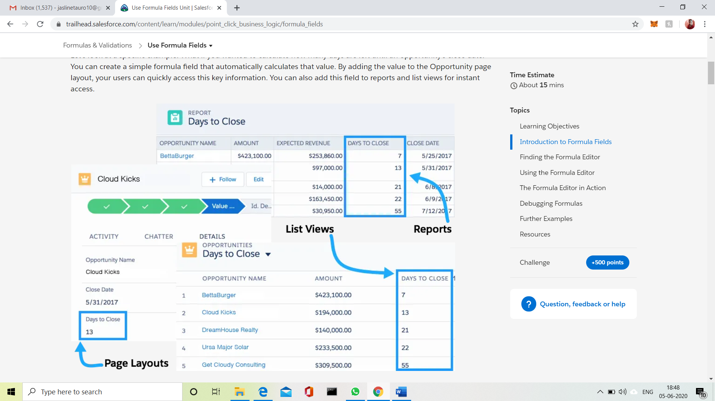

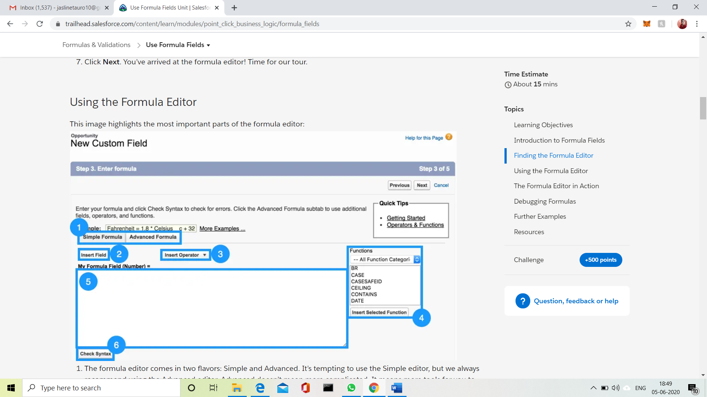

**CODING CHALLENGES DETAILS:**

**Problem statement:**

Write a Java Program to find the duplicate characters in a string.

